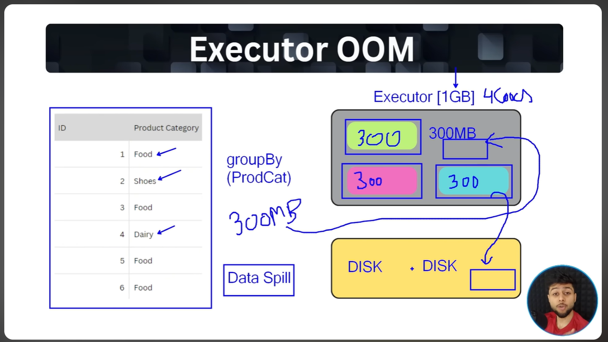

If the size of the data to group exceeds the executor memory, the executor parks the partition containing the data in the disk and this is known as Data Spilling , remember it cannot move the part of partition either it will move the entire partition or it won’t.

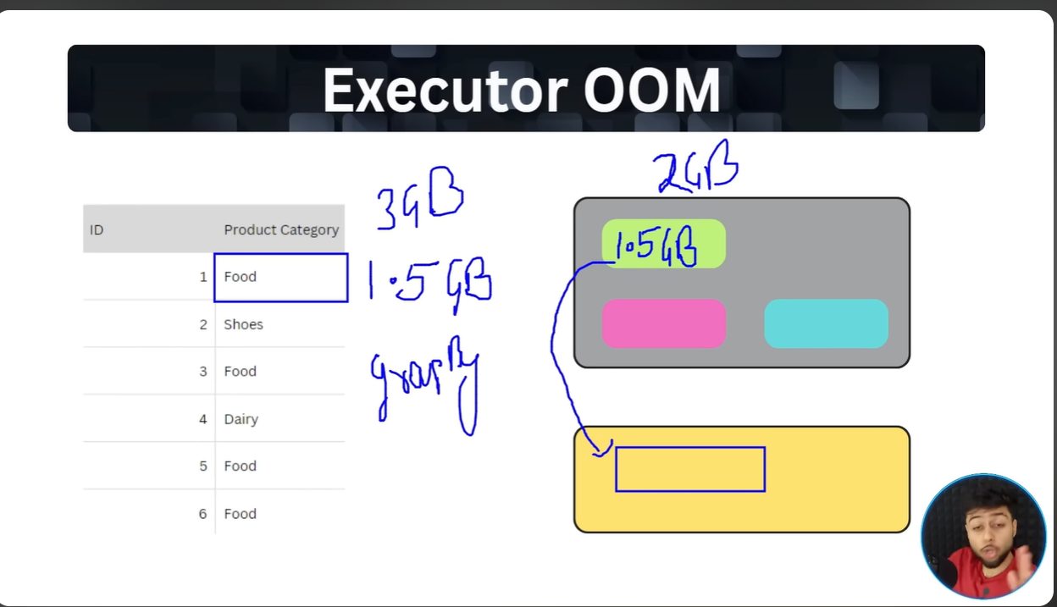
Here , when size of the partition containing data exceeded the executor’s memory due to data skewness , now when this skewness grows beyond data spill not enough to process the data the executor oom is thrown.

